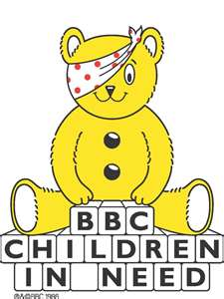

**CHILDREN IN NEED DAY**

**FRIDAY 15th NOVEMBER 2024**

Dear Parents / Carers,

To support Children in Need this year, on Friday 15th November 2024 we are asking the children to come to school dressed in anything bright and cheerful.

Please do not feel that you need to go out and buy anything especially for this day. We are asking, if you are able, for a donation of a silver coin, whether this be 5p up to 50p. Please send in your donation into school with your child on the day and their class teacher will collect it in.

Thank you for your continued support.

Yours sincerely

Ms S M Collins

School Business Director

Executive Head Teacher’s PA