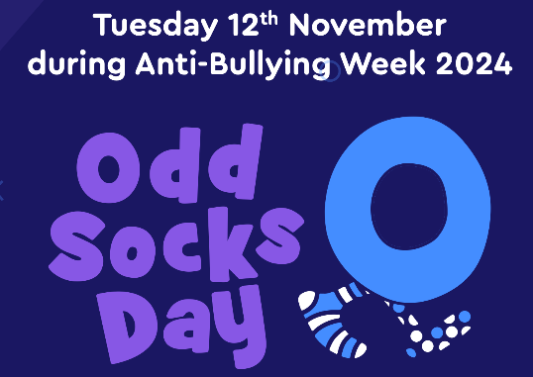

**Odd Socks Day - Tuesday 12th November 2024**

Dear Parents / Carers,

Whether it is verbal, physical, online or in-person, bullying has a significant impact on a child’s life well in to adulthood. The Anti-Bullying Alliance, together with Abbey, is urging action for this year’s Anti-Bullying Week and saying that by making small, simple changes, we can break this cycle and create a safe environment for everyone.

‘Choose Respect’ is the 2024 theme and compliments the Abbey messages - ‘Be A Buddy Not A Bully’ and ‘Abbey Let’s Start S.T.O.P’. The STOP message helps us to have an assertive phrase; ‘STOP! I don’t like that’. S.T.O.P helps us to define bullying ; **S**everal **T**imes **O**n **P**urpose and it helps children to decide what to do if they feel that they are being bullied; **S**tart **T**elling **O**ther **P**eople. Simple, everyday acts of kindness, compassion, smiling, friendship, listening to others and stopping to think before we say a hurtful word or hit ‘like’ on a hurtful social media post, can help to reduce bullying.

CBeebies star and Anti-Bullying Alliance patron Andy Day and his band, Andy and the Odd Socks, are supporting Anti-Bullying Week 2023 and are encouraging children to wear odd socks to school to celebrate what makes us all unique. There is no pressure to wear the latest fashion or for parents to buy expensive costumes.  **All you have to do to take part is wear odd socks to school on Tuesday 12th November, it couldn’t be simpler!**

Thank you for your continued support.

Yours sincerely

Ms S M Collins

School Business Director

Executive Head Teacher’s PA