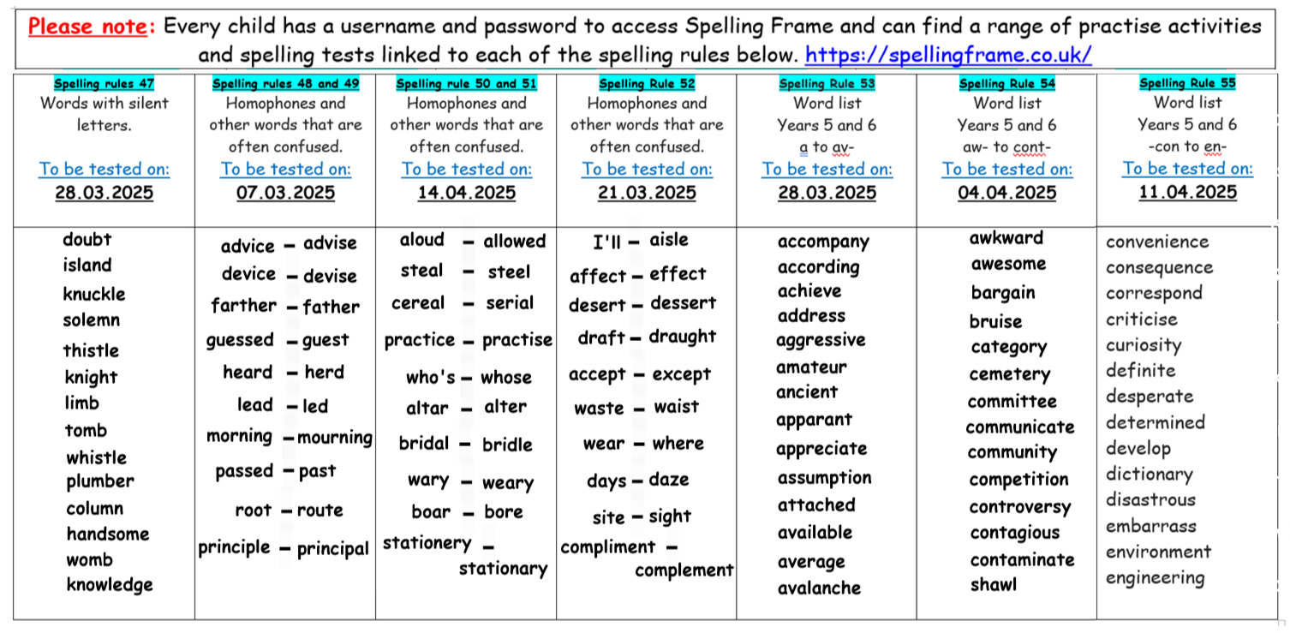Year 5 Spellings – Spring 2