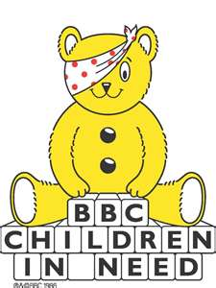

**CHILDREN IN NEED DAY**

**FRIDAY 17th NOVEMBER 2023**

Dear Parents / Carers,

To support Children in Need Day this year on Friday 17th November 2023 we are asking the children to come to school dressed in anything bright and cheerful.

Please do not feel that you need to go out and buy anything especially for this day and we will not be collecting donations.

Anyone wishing to donate can do so directly by following the link below:

https://donate.bbcchildreninneed.co.uk/

Thank you for your continued support.

Yours sincerely

Ms S M Collins

School Business Director

Executive Head Teacher’s PA